**Lab 6: Operational Amplifiers**

**Objective:**

Introduce students to the design of and use of common operational amplifier (Op Amp) circuits.

**Equipment and Components:**

1. DC Power Supply
2. Digital Multimeter
3. Function Generator
4. Breadboard
5. Resistors: 500 Ω, 10 kΩ, plus any additional ones from your design.
6. Multisim or any SPICE simulation software

**Preliminary:**

*Many circuits utilize specially designed circuits that have been integrated into a single package. These Integrated Circuits (IC’s) are designated via a number systems specified by the original design company. Replacement manufactures may add a couple of prefix or suffix letters to identify specific features of the similar IC’s but the number portion will remain constant.*

1. For this lab, search the internet to find the data sheet for a LM 348N (manufacture independent). Paste a copy of the page with the pin diagram into your lab book. *Make sure you know where to apply the positive & negative power supplies, the positive & negative inputs, and where the output is taken. You can use one or more of the four op-amps*.
2. Design the following circuits using an LM348N op-amp chip (or equivalent) with power supply voltages of Vcc+ = +15V and Vcc- = -15V, and feedback resistor, Rf = 10 kΩ. Draw circuit diagrams of each, **showing the** **op amp pin numbers** so that you will be able to follow it in constructing the circuits using Spice and on your proto-board.
3. Inverting amplifier with a voltage gain of 10.
4. Non-inverting amplifier with a gain of 11.
5. Simulate your designs of the two amplifier circuits from Preliminary Part 2. Set the rail voltages at +15 and -15 Volts for the op-amp model.

***Hint:*** In Multisim, Place Component->Master Database->Analog->OpAmp->LM348N (choose A for inverting amp and choose B for non-inverting amp).

1. Sweep the input voltages from -5 to 5 V to verify saturation of the output (i.e. the output will not change after a certain input level)
2. Replace the voltage source with sine wave of Vpp=2.8 V at frequency=1 kHz (end time=0.01 s, max time step tmax=1e-6). Perform Transient analysis and observe the output.
3. Include the results of both DC sweep and Transient Analysis in your lab book.
4. We will use the Function generator and AC (alternating current) part of the DMM for part of this lab. Familiarize yourself with the operations of both the Function generator and AC part of the DMM by reading the Appendix and record any key concepts in your lab book.

**Procedure:**

General purpose op-amps can be found in various packages under various part numbers. For this lab please use an LM 348 or equivalent (i.e. 741).

**Warning:** Turn off all power supplies to your circuit before making modifications to your circuits. Failure to do so will probably destroy your op-amp in some esoteric way resulting in unpredictable behavior of your circuit. Use the pin diagram/ data sheet for wiring information on the op-amp.

1. Assemble the inverting amplifier on the breadboard as designed in the preliminary with power supplies adjusted to + 15 V.

*NOTE:* *To attain + 15 V power supplies connect two floating power supplies in series and use the common node as the reference (ground) point for the circuit. (Figure 6.2)*

1. Connect a sinusoidal signal with a peak voltage of 1.4 V (1 VRMS or 2.8 Vpp) at 1 kHz and set the DMM on AC Voltage or Current.
2. Calculate the voltage gain. (Gain = Output Voltage / Input Voltage.)
3. Measure the voltage across the op amp inverting (-) and non-inverting (+) input terminals. Is this a “virtual” short?
4. Measure the current flowing into the inverting (-) and non-inverting (+) op-amp input terminal. From the voltage measured in part *c* and the current in part *d*, estimate the op-amp input resistance.
5. Slowly increase the input voltage until the op-amp enters saturation (the output becomes limited), noting the input voltage where this occurs.
6. Increase the input voltage by 1 V above the value found in part e and measure the voltage across the op amp inverting (-) and non-inverting (+) input terminals. Is this a “virtual” short?
7. Change the circuit to the non-inverting amplifier as designed in the preliminary. Repeat the measurements of Procedure part 1 and record all values in your lab book.
8. The operational amplifier, or op-amp circuit shown in Figure 6.1 is proposed as an ohmmeter to measure unknown resistances. Find a value for R1 so that a voltmeter connected to the output will read the resistance in kilo-Ohms (eg. 1 V = 1 kΩ, 2 V = 2 kΩ). Create the circuit and perform the following experiment while recording the data in a single table.
9. Using the laboratory multimeter, measure the resistance of four different resistors between 500 Ω and 10 kΩ.
10. Measure the resistance of each resistor using your op-amp Ohmmeter (Figure 6.1).
11. Calculate the percentage error of measurement of your designed circuit in comparison to the laboratory multimeter for each of the five resistors.



Figure 6.1: Ohmmeter using Op-amp

**Conclusion:**

Discuss your general op-amp observations. Including issues related to rail voltages, opamp response, and a comparison of calculated values, simulated values, and experimental values. In addition, compare how well your Ohmmeter determines resistance.

**Appendix**

**Function Generator:**

The output of the function generator will be in the following form:



However, you only need to pay attention to Vp (the peak voltage level) and ω(the frequency, ω = 2 π f) for this lab. This can be controlled directly from the front panel of the Function Generator by selecting the appropriate button or soft key and inputting the desired value. In addition, modern function generators commonly “display” a graphical version of what it should be outputting (i.e. try to model the generator as an IDEAL SOURCE). But in order to calibrate the display and values, you must set specify the type of load that the generator will be driving. Otherwise it will be unable to back out the internal resistance of the generator. To calibrate the generator select:

[Output Menu => Load Impedance => 50Ω, Load, or High Z]

* 50 Ω is used for normal AC operations
* Load does not back out the Source Resistor
* High Z is used for “open circuit” type connections.

You should use the High Z for this lab.

**DMM:**

Modern Digital Multi Meters (DMMs) are capable of measuring DC values, AC Peak values, and DC equivalent of AC readings commonly called RMS. Hence, users can measure both AC and DC values for advance circuits (remember superposition). When a user tries to use the DC setting on an AC circuit, the readings will either display the “Offset” or the DC part of the source, or if the frequency is slow enough it will display a real time readout. Users must select the AC settings in order to measure the Alternating Part, which can either be displayed as the Peak value or the RMS value. Where the RMS value is the DC equivalent that would dissipate the same power as the AC signal.

**Power Supply:**

To create + 15 V and -15 V power supplies, connect two floating power supplies in series and use the common node as the reference (ground) point for the circuit (please see the picture shown below).

Make sure that you first measure the output of the power supplies to ensure V+ = 15 V and V- = -15V using Multimeter before connecting them to your circuit. Be careful when you connect the power supplies (high voltage on wrong pins will destroy the op amp). Turn up the voltage slowly from 0 to 15 V.

Please make sure that all the grounds in the circuit as well as the ones from the oscilloscope, function generator, and the power supply are connected together as a single ground.

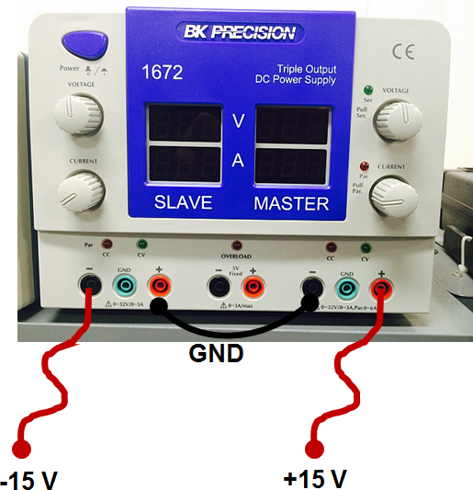

Figure 6.2: Using a DC power supply to generate +15V and -15V.